
PROJECT REPORT · DATA STRUCTURES AND ALGORITHMS LABORATORY
CholoKUET
A KUET campus navigator built on stacks, queues, trees and graphs
Department: Computer Science and Engineering
Institution: Khulna University of Engineering & Technology (KUET)
Course: Data Structures and Algorithms Laboratory
Submitted to:
Subah Nawar, Lecturer, Department of CSE, KUET
Lamisa Bintee Mizan Deya, Lecturer, Department of CSE, KUET
Course teachers, Data Structures and Algorithms Laboratory
Date of submission: 5 October 2025
Source code: github.com/ettisafxrup/CholoKUET
SUBMITTED BY
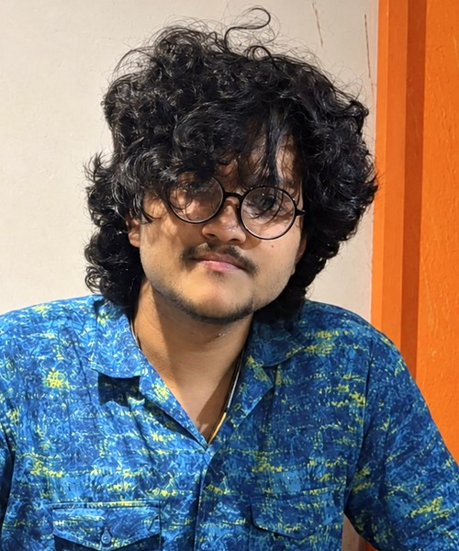 | Ettisaf Rup  Undergraduate, CSE, KUET  Roll: 2407109 |  | Afia Anjum Broti  Undergraduate, CSE, KUET  Roll: 2407096

Contents
1. Introduction 3
1.1 The problem 3
1.2 Motivation 3
1.3 Objectives 3
1.4 Scope 3
2. How the Marking Scheme Is Covered 4
3. Where We Used What 6
3.1 Tools and technologies 6
3.2 Every source file and what it holds 6
4. How the Application Works 8
4.1 Starting up 8
4.2 Logging in 8
4.3 The main menu 8
4.4 "Take me somewhere", step by step 9
4.5 The other features 10
4.6 Saving and closing 10
5. System Design 11
5.1 Architecture 11
5.2 Data files 11
5.3 Where the map came from 11
6. Data Structures 13
6.1 Array: the place list 13
6.2 Linked list: searches, favorites and routes 13
6.3 Stack (hand-written) 13
6.4 Queue (hand-written, circular) 13
6.5 Tree: browsing by category 14
6.6 Graph: walkways 14
7. Algorithms 15
7.1 Breadth-first search 15
7.2 Rebuilding the route 15
7.3 From a route to directions 15
7.4 Depth-first search 15
7.5 Linear and binary search 16
7.6 Bubble sort and selection sort 16
7.7 Distance and direction 16
8. Complexity Analysis 17
9. Testing 18
Problems we found and fixed 18
10. A Walk Through the App 19
10.1 Starting up and signing in 19
10.2 Take me somewhere 20
10.3 What's near me and the place page 21
10.4 Explore the campus 21
10.5 Search and sort 22
10.6 Location, history and favorites 22
11. Limitations 24
12. How We Can Improve It 25
12.1 Better routes 25
12.2 Better data 25
12.3 Better experience 25
12.4 Better engineering 25
References 26
Appendix A. Data Structure Walkthroughs 27
A.1 Array 27
A.2 Linked list 27
A.3 Stack (hand-written, dsa/stack) 27
A.4 Queue (hand-written circular queue, dsa/queue) 28
A.5 Tree 28
A.6 BFS from the main gate to the Central Library 29
A.7 Linear and binary search 31
A.8 Bubble sort and selection sort, pass by pass 31
Appendix B. Building and Running 33

1. Introduction

1.1 The problem
Every year a new batch arrives at KUET and spends its first few weeks getting lost. The campus covers about 117 acres and has more than forty buildings, many known only by short forms such as "ACA building", "ME building" or "Kodom Tola". Nothing on the ground tells you that CSE, ECE and IEM share one building, or that the quickest walk from the main gate to the library goes past the halls. Visitors have it harder still, and even students who have been here for years often can't say how far the medical centre is from Lalan Shah Hall.
We wanted to find out how far a small program could get with those everyday questions, using only the data structures from this course.

1.2 Motivation
Most lab work practises each data structure alone: push three numbers, pop two, print the stack. That works, but it never shows why a stack exists. Campus navigation turned out to need almost everything in the syllabus. Walkways between buildings form a graph. Finding a route is BFS. The Back button is a stack. Building categories form a tree. Finding a place by name is searching, and listing places by distance is sorting. Here, every structure has a job to do.

1.3 Objectives
- Build a working navigator for the KUET campus that runs offline on any Windows PC.
- Write the stack and the queue ourselves and use them where they matter: BFS, DFS, navigation history and route reversal.
- Use real campus coordinates that we can defend, not invented positions.
- Turn a route into directions a person can follow: which roads to take, where to turn, what you pass on the way, and how long it takes.
- Let the program show its own working (the BFS queue, the DFS stack), so each structure can be seen during the viva.

1.4 Scope
CholoKUET covers 44 places on the main campus (departments, halls, the library, the auditorium, the medical centre, landmarks such as Durbar Bangla and the Central Shaheed Minar) connected by 56 walkways on 15 named roads. It works at the level of buildings, not rooms, and it does not read live GPS: the user types a place or a pair of coordinates. The name CholoKUET comes from "Cholo Explore Kore Ashi" ("come on, let's go explore"), because the project started with a simple question: could we build a map of our own campus ourselves?

2. How the Marking Scheme Is Covered
This chapter maps each part of the tentative marks distribution to the feature and source file that covers it, so any part can be found quickly during the evaluation.
The lab required us to write the stack and queue by hand; the other containers could come from the STL. Every algorithm that runs on them (BFS, DFS, linear and binary search, bubble and selection sort) is our own code. Running make check-manual confirms that std::stack, std::queue and std::sort appear nowhere in the program.
Marking area | Marks | Where it is covered in the app | Where it is in the code
Array | 5 (with LL, Stack, Queue) | The list of all 44 places, used by every search, sort and "nearest place" lookup | Campus::locations (std::vector<Location>) in include/Campus.h, src/Campus.cpp
Linked list |  | Recent searches (newest first, last 10), favorites, and every BFS route | std::list<int> in include/Navigator.h; Graph::findRoute() returns std::list<int>
Stack (hand-written) |  | DFS, the Back button in Trip history, turning the BFS route the right way round, removing a deleted place from history | dsa/stack/Stack.h, dsa/stack/Stack.cpp; used in src/Graph.cpp, src/Places.cpp, src/NavigatorAdmin.cpp
Queue (hand-written, circular) |  | BFS for every route in "Take me somewhere" and "Take me here" | dsa/queue/Queue.h, dsa/queue/Queue.cpp; used in Graph::findRoute()
Tree | 5 | Browse by category (menu 5): KUET → category → place; rebuilt after every admin change | include/CampusTree.h, src/CampusTree.cpp: build, addChild, find, remove, print, countNodes, height
BFS | 3 (with DFS, Searching) | Take me somewhere (menu 1), "Take me here" on a place page, and the step-by-step "Show how BFS found this route" | Graph::findRoute() and Graph::rebuildRoute() in src/Graph.cpp
DFS |  | Explore the campus (menu 3), the connectivity check, the warning after an admin deletes a place or walkway | Graph::depthFirstOrder(), Graph::isConnected() in src/Graph.cpp
Searching |  | Search (menu 4), and every "which place?" prompt; binary search for exact names | src/Search.cpp: linearSearchByName, linearSearchByCategory, linearSearchById, binarySearchByName
Sorting | 2 | Sort places (menu 6); What's near me (menu 2); sorting a copy before binary search | src/Sort.cpp: bubbleSortByName, selectionSortByName, selectionSortByCategory, bubbleSortByDistance
Presentation | 5 | Slide deck with a recorded walkthrough of the app, a live demo plan, logo and generated campus map | presentation/CholoKUET Presentation.pptx, assets/
Q&A and Report | 5 | This report, 55 viva questions with answers, the DSA mapping, 907 unit checks | presentation/, docs/viva-questions.md, docs/dsa-mapping.md, tests/

3. Where We Used What

3.1 Tools and technologies
What | Used for
C++17 | The whole application
Standard library | vector (array), list (linked list), map and set (graph storage, visited sets), deque (last log lines), string, function
termcolor (third_party, BSD licence) | Coloured terminal output in KUET gold, wrapped in our own Style module
g++ 16 (MSYS2 UCRT64), GNU Make, CMake | Building the program and the tests; static linking so the .exe runs on any PC
windres | Putting the CholoKUET logo and version details into CholoKUET.exe
OpenStreetMap | Surveyed coordinates for 38 of the 44 places and the campus outline
KUET master plan | The road layout, and the position of six buildings OSM does not have
Node.js | tools/render-map.js, which draws the campus map from our data files
Git and GitHub | Version control; the code is at github.com/ettisafxrup/CholoKUET

3.2 Every source file and what it holds
File | What it does | Structures / algorithms inside
main.cpp | Starts the app; can also build the whole program on its own | -
dsa/stack/Stack.cpp | Our array stack | Stack
dsa/queue/Queue.cpp | Our circular queue | Queue
src/Graph.cpp | Walkway graph, BFS, route rebuild, DFS, connectivity | Graph, BFS + Queue, DFS + Stack, linked list
src/Trip.cpp | Turns a BFS route into roads, turns, stops and time | Linear pass over the route list
src/CampusTree.cpp | The category tree | General tree, preorder traversal
src/Campus.cpp | Loads, checks and saves every data file | Array of places, graph
src/Search.cpp | Linear and binary search | Searching
src/Sort.cpp | Bubble and selection sort with counts | Sorting
src/Distance.cpp | Haversine distance and compass bearing | -
src/Navigator.cpp | Startup, login, main menu, "which place?" prompts | Linear search, history Stack, recent-search list
src/Trips.cpp | Take me somewhere, What's near me, Explore | BFS, DFS, bubble sort
src/Places.cpp | Search, place pages, categories, sorting, history, favorites | Search, sort, tree, stack, lists
src/NavigatorAdmin.cpp | Adding, editing and deleting places and walkways | Array, graph, tree rebuild, stack rebuild
src/Authentication.cpp, Logger.cpp, Style.cpp, Utils.cpp | Accounts, activity log, colours, safe input | -
tests/*.cpp | Eight unit-test programs | Checks for every structure

4. How the Application Works
This chapter follows the program from start-up to shutdown, then walks through the main feature step by step.

4.1 Starting up
- main() creates the Navigator object and calls initialize().
- The program looks for data/locations.txt in the current folder and up to three folders above it, so it works whether it is started from the project folder, from bin/, or from a CMake build folder.
- It turns on UTF-8 output and colours, creates data/ and logs/ if they are missing, and opens the activity log.
- Campus loads the categories, then the places into the array (each becomes a graph vertex), then the walkways into the graph. Broken or repeated lines are skipped and reported, and never stop the program.
- The category tree is built from the loaded places.
- Authentication loads the accounts. If there are none, it creates admin / admin123 and student1 / student123.
- A quick DFS checks that every place can be reached, and warns if not.

4.2 Logging in
The login screen offers Log in, Create an account and Exit. Passwords are hidden with * while typing. Usernames are checked (3–30 letters, digits, _ or .), and passwords are stored as a 64-bit FNV-1a hash of "username:password". After a successful login the session starts fresh: an empty history stack, an empty recent-search list, no current location, and the user's saved favorites list loaded from data/favorites.txt.

4.3 The main menu
# | Menu item | What happens | Structure used
1 | Take me somewhere | Asks where you are and where you want to go, then gives directions | Graph, BFS + Queue, Stack, linked list
2 | What's near me | The 10 closest places with distance, direction and walking time | Array, Haversine, bubble sort
3 | Explore the campus | DFS order from a place, connectivity check, all roads | DFS + Stack
4 | Search | One box for names, categories and numbers | Linear + binary search, linked list
5 | Browse by category | KUET → category → place | Tree
6 | Sort places | A–Z, Z–A, category, distance, with counts | Bubble + selection sort
7 | Where am I? | Set your location by place or coordinates; copy it | Linear scan, Haversine
8 | Trip history | Every place you have been; Back returns to the last | Stack
9 | Recent searches | The last 10 places you searched for | Linked list
10 | Favorites | Starred places, saved per user | Linked list
11 | Help | How to use the app and how it works | -
12–15 | Admin only | Manage places, manage walkways, users, activity log | Array, graph, tree

Everywhere in the app, pressing Enter on its own goes back, and a place can be typed as part of its name (lib), its number from the campus map (3), or coordinates (22.8992, 89.5016).

4.4 "Take me somewhere", step by step
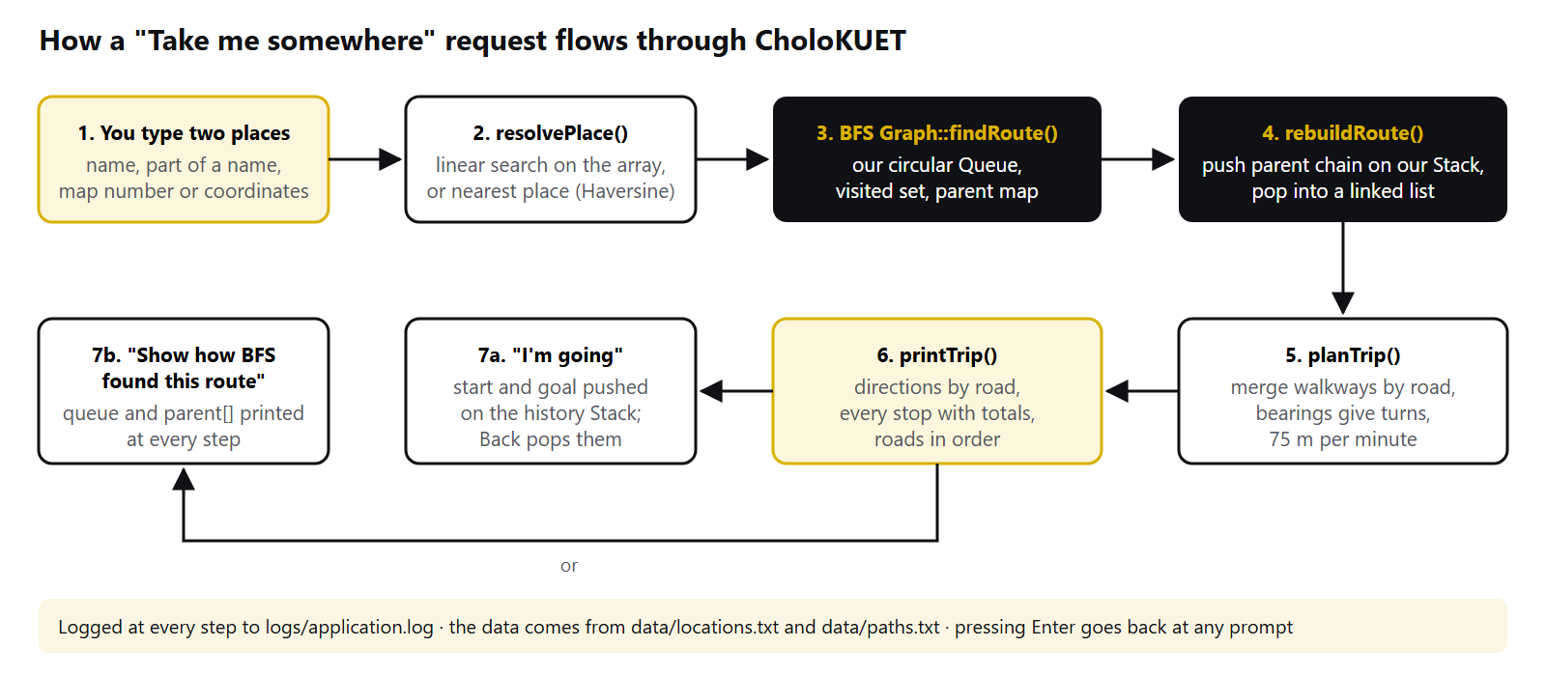
Figure 1. How a trip request travels through the code.
- Where are you? The answer goes to resolvePlace(). Coordinates are matched to the closest place by computing the Haversine distance to all 44 places. A number is looked up by ID. Text is matched by linear search on names, then on categories. If several places match, the user picks one from a numbered list. Pressing Enter uses the current location.
- Where do you want to go? The same process gives the destination.
- BFS (Graph::findRoute) starts at the start place, puts it in our queue and marks it visited. It repeatedly dequeues a place and enqueues every unvisited neighbour, recording parent[neighbour] = current. It stops when the destination is dequeued.
- Rebuilding the route (rebuildRoute): following parent from the destination gives the route backwards. Each place is pushed on our stack, and popping them all gives the route in forward order, stored in a linked list.
- Planning the trip (planTrip): walking along the route once, walkways on the same road are merged into one step, and the places in between become "places you pass". Where the road changes, the compass bearings of the two walkways decide turn left, turn right or continue straight. Each step gets a direction, a length and a walking time at 75 m a minute.
- Showing it (printTrip): a summary line, directions by road, a table of every stop with leg and running distances, and the roads in order.
- Afterwards the user can choose I'm going, which pushes the start and destination onto the history stack so Back can undo it, or Show how BFS found this route, which runs BFS again and prints the queue and parent at every step.

4.5 The other features
- What's near me works out the distance from a point to every place in the array, sorts them with bubble sort, and shows the nearest ten with a compass direction and walking time.
- Explore the campus runs DFS from a chosen place (optionally showing the stack at every step), checks whether every place can be reached, and lists every road with its walkways.
- Search runs binary search on a sorted copy to find an exact name first, then linear search for partial name and category matches. Opening a result adds it to the recent-search list.
- Browse by category walks the tree: pick a category (a child of the root), then a place (a leaf).
- Trip history shows the stack from top to bottom. Back pops the top and moves you to the new top.
- Admin edits keep every structure consistent. Adding a place adds it to the array and the graph. Deleting one removes it from the array, the graph (with its walkways), the favorites and recent lists, and the history stack (by popping everything onto a second stack and pushing the rest back). Every change rebuilds the tree and is saved to the data files straight away.

4.6 Saving and closing
Every change is written to disk as it happens: places to locations.txt, walkways to paths.txt, accounts to users.txt, favorites to favorites.txt. Every login, search, route, DFS and admin action is logged to logs/application.log with a timestamp, and passwords are never logged. On Log out the session state is cleared; on Exit the program says goodbye and closes.

5. System Design

5.1 Architecture
We split the program into three layers. The top layer is the menus (Navigator, split across four files), which only talk to the user. The middle layer is the campus model (Campus), which owns the places, the categories and the graph, and is the only code that reads or writes the data files. The bottom layer holds the data structures and algorithms, which know nothing about menus or files. Because of this split, the stack can be opened and explained on its own, and the same core could later sit under a graphical app.
Terminal menus (Navigator)
| | |
Authentication Campus Logger, Style
|
+------------------+-------------------+
| | |
places (array) Graph (walkways) CampusTree
| |
BFS + our Queue DFS + our Stack
|
data/*.txt files

5.2 Data files
File | One line looks like | Notes
data/locations.txt | 3|Central Library|Facility|22.899247|89.501796|Central library of KUET | ID, name, category, latitude, longitude, description
data/paths.txt | 4|3||Academic Walk | From, to, meters (empty = straight line), road name
data/categories.txt | Academic | Order of categories in the tree
data/users.txt | student1|445aff2fe080879e|student | Username, password hash, role
data/favorites.txt | student1|3 | Username and place ID

5.3 Where the map came from
We started from the Proposed Revised Master Plan of KUET Khulna Campus, but a drawing has no coordinates. OpenStreetMap had the campus outline and about forty named buildings, all surveyed on the ground, so we used those coordinates for 38 of our places. For the six buildings OSM does not have yet (Fazlul Haque Hall, the Central Mosque, the Canteen, the Garage, the Dormitory and Kodom Tola), we measured 18 buildings that appear in both the plan and OSM and fitted a least-squares affine transform from plan pixels to latitude and longitude. The fit differs from OSM by 27 m on average, about the width of one building, which also shows the plan's layout is accurate. The 56 walkways follow the roads on the plan. KUET Road and Khanjahan Ali Hall Road are OSM names; the other road names are our own descriptive labels.
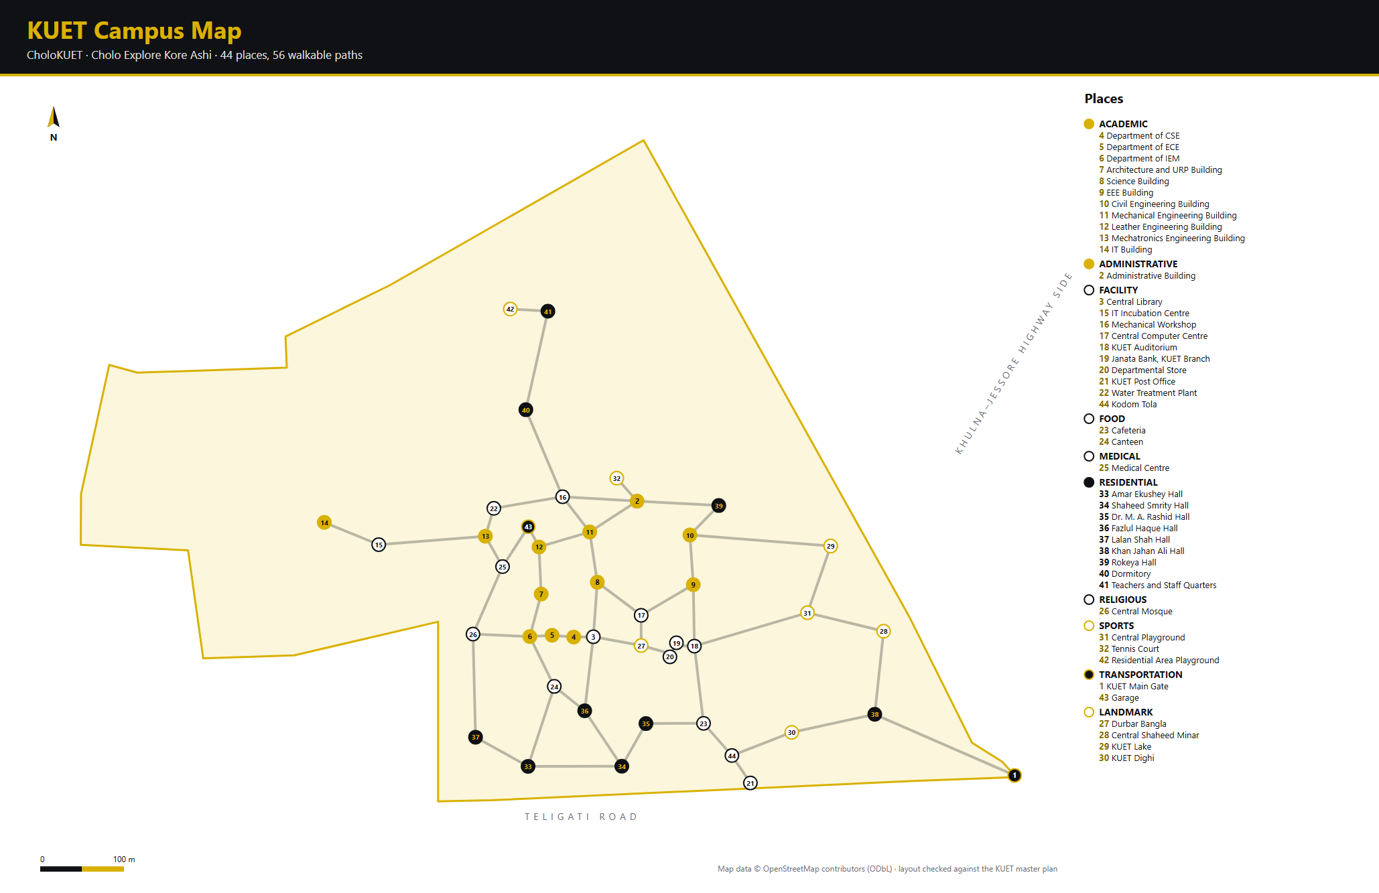
Figure 2. The campus as CholoKUET sees it, drawn from its own data files. The numbers are place IDs. Map data © OpenStreetMap contributors.

6. Data Structures

6.1 Array: the place list
All 44 places live in a std::vector<Location>. Reading by index is O(1), which suits a list that is read constantly and changed only by an admin. We never assume a place's ID equals its index: after a delete everything shifts left, so every lookup goes by ID.

6.2 Linked list: searches, favorites and routes
Recent searches are a std::list<int>. A new search goes to the front; if the place is already there it is moved rather than duplicated; after ten, the oldest drops off the back. All of these are cheap on a linked list. The route that BFS returns is also a list, because its length is not known until the search ends and we only ever walk it front to back.

6.3 Stack (hand-written)
An array of 200 integers and one index, top. An empty stack has top = -1. push moves top up and writes; pop reads and moves it down. Both refuse instead of writing outside the array (overflow and underflow).
bool Stack::push(int value)
{
if (isFull())
return false; // overflow

data[++top] = value;
return true;
}
Used for DFS, the Back button, reversing the BFS route, and removing a deleted place from the middle of the history.

6.4 Queue (hand-written, circular)
A plain array queue wastes every slot it has already dequeued. Ours wraps round with % CAPACITY, so the rear moves back to slot 0 once the front has moved on. A separate count tells a full queue from an empty one.
bool Queue::enqueue(int value)
{
if (isFull())
return false; // overflow

rear = (rear + 1) % CAPACITY;
data[rear] = value;
count++;
return true;
}
Used for BFS in every route.

6.5 Tree: browsing by category
KUET is the root, each category is a child, and each place is a leaf. Each node keeps its children in a vector, so a category can hold any number of places (Academic has eleven, Medical has one); a binary tree would force artificial splits. Children are stored inside their parent, so removing a node removes its whole subtree. The campus tree has 55 nodes and a height of 3.
struct TreeNode
{
std::string name;
int locationId = -1; // -1 for the root and category nodes
std::vector<TreeNode> children;
};

6.6 Graph: walkways
Every place is a vertex and every walkway an undirected edge with a length in meters and a road name. We use an adjacency list, because the campus is sparse: 44 vertices and only 56 edges. A matrix would be mostly empty, and scanning a row would cost O(V) even for a place with two neighbours.
struct Edge
{
int to;
int meters;
std::string road;
};

std::map<int, std::vector<Edge>> adjacency; // place ID -> its walkways

7. Algorithms

7.1 Breadth-first search
BFS explores outwards one ring of neighbours at a time using our queue. A neighbour is marked visited when it is enqueued, not when it is dequeued, which stops the same place from being queued twice. In an unweighted graph BFS gives the route with the fewest stops. Our walkways have different lengths, so that is not always the shortest walk in meters, and the app shows both the walking length and the straight-line distance.
while (!queue.isEmpty())
{
int current;
queue.dequeue(current);
if (current == goal)
break;

for (const Edge& edge : neighbors(current))
{
if (visited.count(edge.to))
continue;
visited.insert(edge.to);
parent[edge.to] = current;
queue.enqueue(edge.to);
}
}

7.2 Rebuilding the route
The parent map describes the route backwards. We follow it from the destination and push each place on our stack; popping gives the forward order. For the gate-to-library route, the library is pushed first and the gate last, so the gate ends up on top (see Appendix A.6).

7.3 From a route to directions
planTrip() walks the route once, so it costs O(k) for a route of k stops:
- Consecutive walkways on the same road merge into one step; the places in between become "places you pass".
- Where the road changes, the bearing of the new walkway is compared with the old one: under 35° is continue straight, over 150° is turn around, anything else is turn left or turn right.
- Each step gets an overall compass direction, a length, and a walking time at 75 m a minute (about 4.5 km/h).

7.4 Depth-first search
Our DFS is iterative. The top of our stack is the place being explored, and for each place we remember how far we have scanned through its neighbours, so after backtracking we carry on from where we stopped. Each place is pushed only once, so the stack never holds more than the number of places. The fixed 200-slot stack therefore cannot overflow, even on a fully connected graph, and one of our tests checks exactly that.

7.5 Linear and binary search
Linear search lowercases both strings and checks whether one contains the other, so lib finds Central Library. Binary search only works on sorted data, so it runs on a copy sorted by name and answers "is there an exact match?". On our 44 places it finds the library in 6 comparisons, where a linear scan checks all 44.
while (low <= high)
{
int mid = low + (high - low) / 2;
int result = compareIgnoreCase(name, sorted[mid].name);
comparisons++;
if (result == 0) return mid;
if (result < 0) high = mid - 1;
else low = mid + 1;
}

7.6 Bubble sort and selection sort
Bubble sort swaps neighbours that are out of order and stops early when a pass makes no swaps. Selection sort finds the smallest remaining item on each pass and swaps it into place. Sorting all 44 places by name, bubble sort made 880 comparisons and 367 swaps; selection sort made 946 comparisons (exactly 44 × 43 / 2) but only 39 swaps. Bubble sort is stable and selection sort is not. "What's near me" sorts 44 distances with bubble sort (931 comparisons, 474 swaps from the main gate).

7.7 Distance and direction
Distances use the Haversine formula with an Earth radius of 6,371 km, accurate to well under a meter over campus distances. Directions use the initial compass bearing between two points (0° north, 90° east), named as one of eight compass points.
a = sin²(Δφ/2) + cos φ1 · cos φ2 · sin²(Δλ/2)
d = 2R · atan2(√a, √(1 − a))

bearing = atan2(sin Δλ · cos φ2, cos φ1 · sin φ2 − sin φ1 · cos φ2 · cos Δλ)

8. Complexity Analysis
Operation | Time | Note
Array access by index | O(1)
Find a place by ID | O(n) | Linear scan
Delete a place | O(n) | Later items shift left
Linked list: insert at front, remove from back | O(1) | Recent searches
Stack push / pop / peek | O(1)
Queue enqueue / dequeue | O(1) | Circular indexes
Tree traversal and search | O(n) | n = number of nodes
BFS, DFS | O(V + E) | Adjacency list; a matrix would make it O(V²)
Turning a route into directions | O(k) | k = stops on the route
Linear search | O(n)
Binary search | O(log n) | Sorted data only
Bubble sort | O(n²) | O(n) when already sorted
Selection sort | O(n²) | At most n − 1 swaps
What's near me | O(n²) | n distances, then bubble sort

Memory is O(V + E) for the graph and O(n) for everything else. The stack and queue are fixed at 200 integers each, and the program never lets the campus grow past 200 places, so neither can overflow during BFS or DFS.

9. Testing
We wrote eight small test programs, one per module, with a tiny CHECK macro of our own. make test builds and runs them all, and any failure stops the run.
Suite | What it checks | Checks
Stack | Empty stack, LIFO order, peek, overflow at 200, underflow | 213
Queue | Empty queue, FIFO order, overflow, wraparound past the end of the array | 419
Graph, BFS, DFS | Reachable, same start and end, unreachable, fewest stops over a longer path, disconnected and connected DFS, deleting a place, a full 200-vertex graph | 26
Tree | Building from data, empty categories, case-insensitive find, removing a subtree | 15
Search | Found, not found, partial and case-insensitive matches, binary search on sorted data | 22
Sort | Empty, one item, already sorted, reverse sorted, duplicates (stability), by category and distance | 13
Trip | Legs merge along one road, left and right turns, compass names, walking time, the trip reversed | 34
Campus data | The real data files load with no bad lines, every walkway has a road name, all places are connected and on campus | 165
Total |  | 907

We also drove the whole program with scripted input as both a student and an admin, through every menu: wrong passwords, letters where numbers were expected, out-of-range choices, mismatched passwords, and adding, editing and deleting places and walkways. The program never crashed, the log recorded every action, and no password showed up in it.

Problems we found and fixed
- DFS could overflow the stack. The textbook "pop, then push every unvisited neighbour" version can push the same place many times, which on a dense graph needs more than 200 slots. We switched to the version that pushes each place once. A test on a complete 200-vertex graph guards against the old behaviour.
- On one PC the program crashed at startup. It was loading an incompatible libstdc++ DLL from another program on the PATH. Linking statically fixed it and made the .exe portable.
- termcolor did not compile with g++ 16, because it uses uint8_t without including <cstdint>. We include it before the library instead of editing the library.

10. A Walk Through the App
The screens in this chapter come from one real session, captured in the order shown. A new student starts the program, makes an account, logs in and tries each menu before leaving. In the terminal, titles and menu numbers appear in KUET gold and hints in grey.

10.1 Starting up and signing in
make run builds the program and opens the welcome screen (Figure 3). A new user chooses Create an account. The rules are printed first, and the password shows as stars while it is typed (Figure 4). After logging in, the main menu greets the user by name and groups its eleven options under Get around, Find and You (Figure 5).
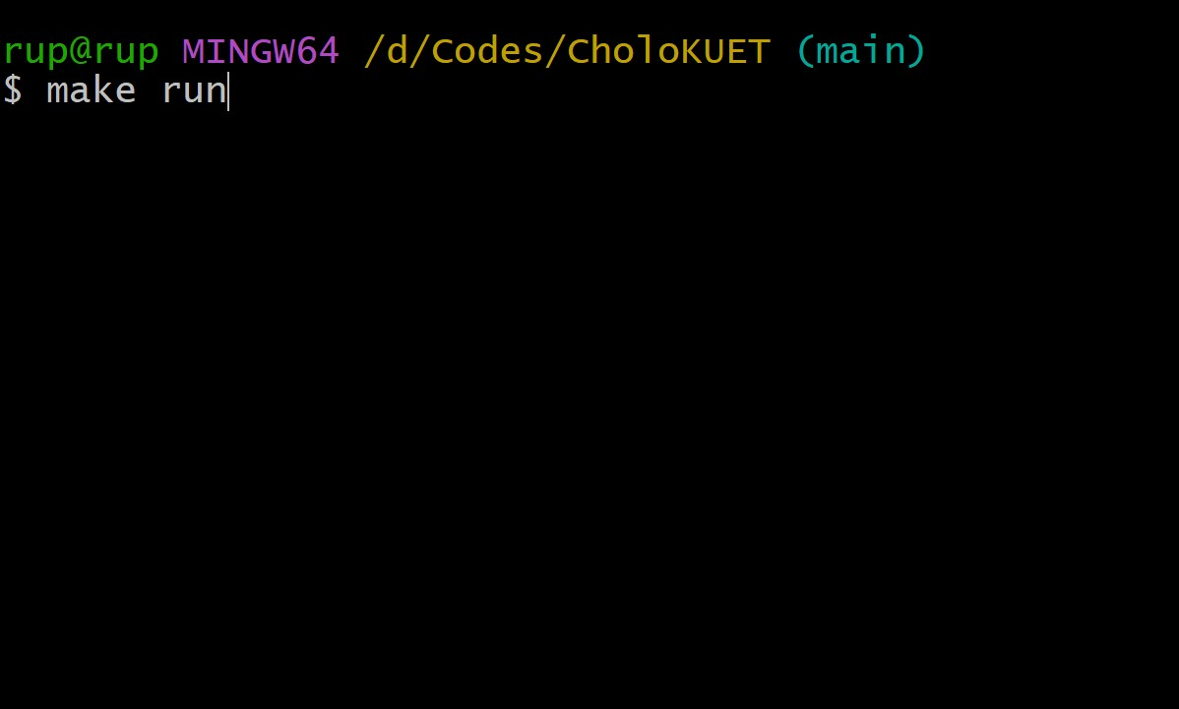 | 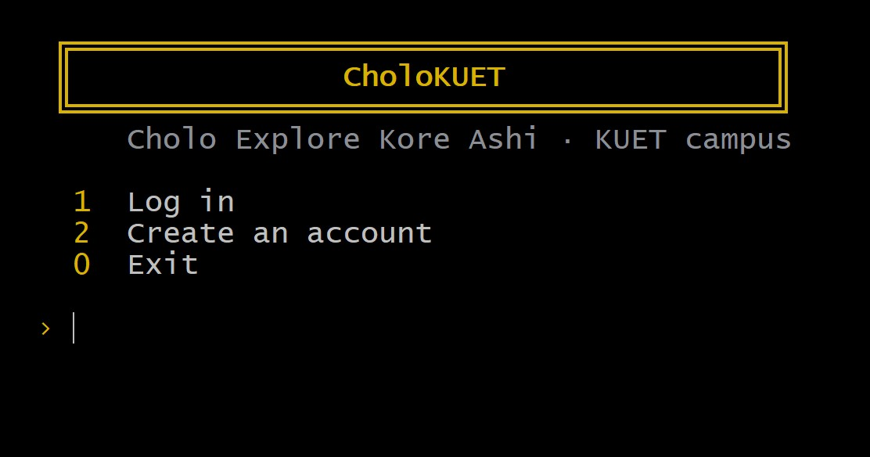
Figure 3. Starting the program with make run (left) and the welcome screen (right).
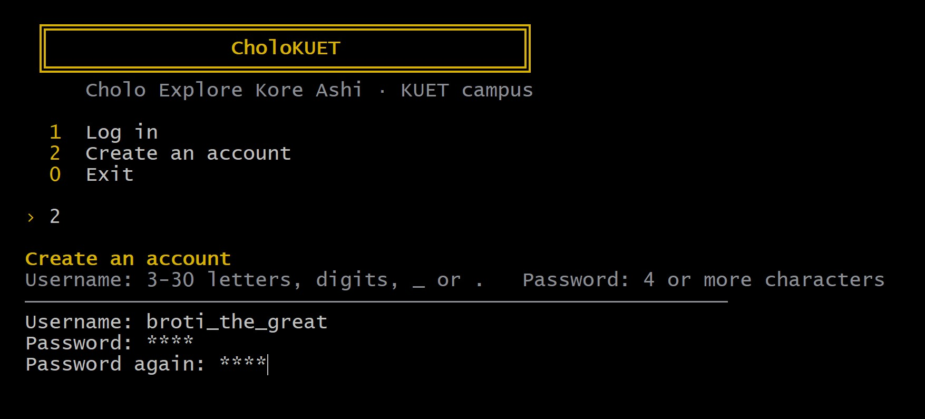 | 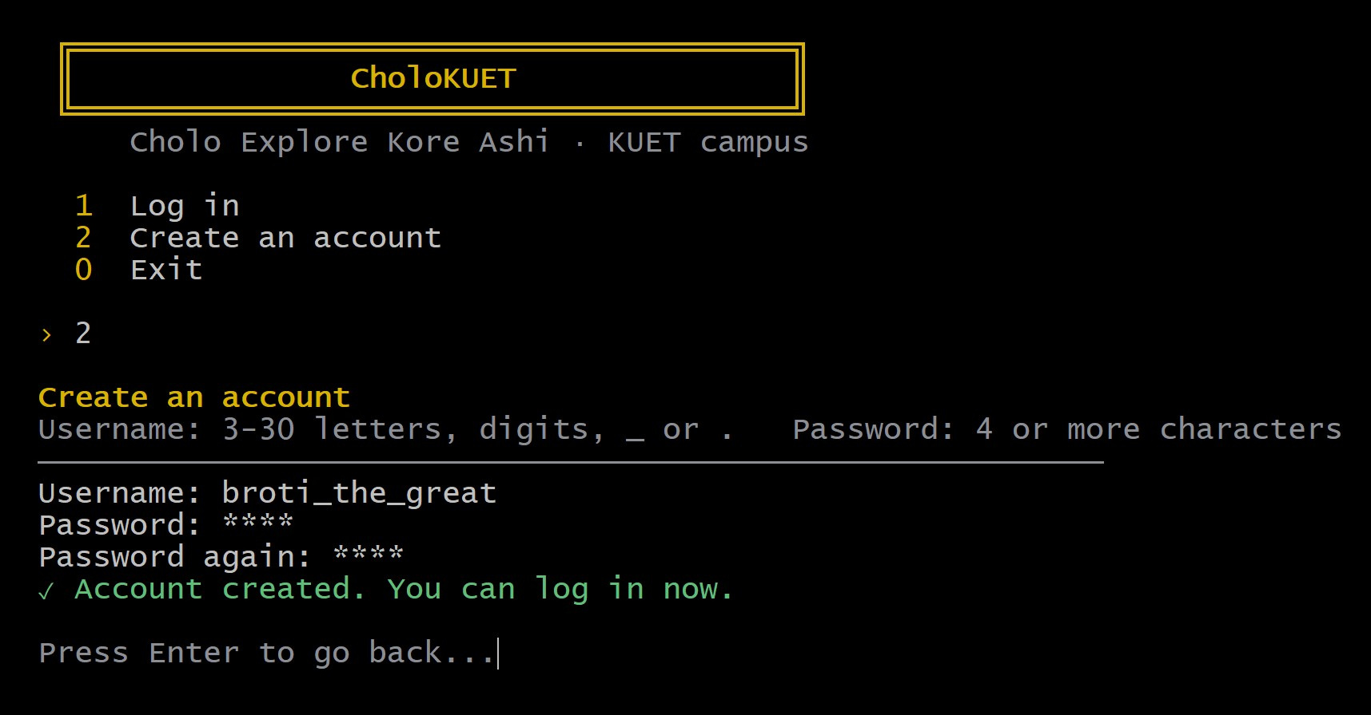
Figure 4. Creating an account: the form (left) and the confirmation (right).
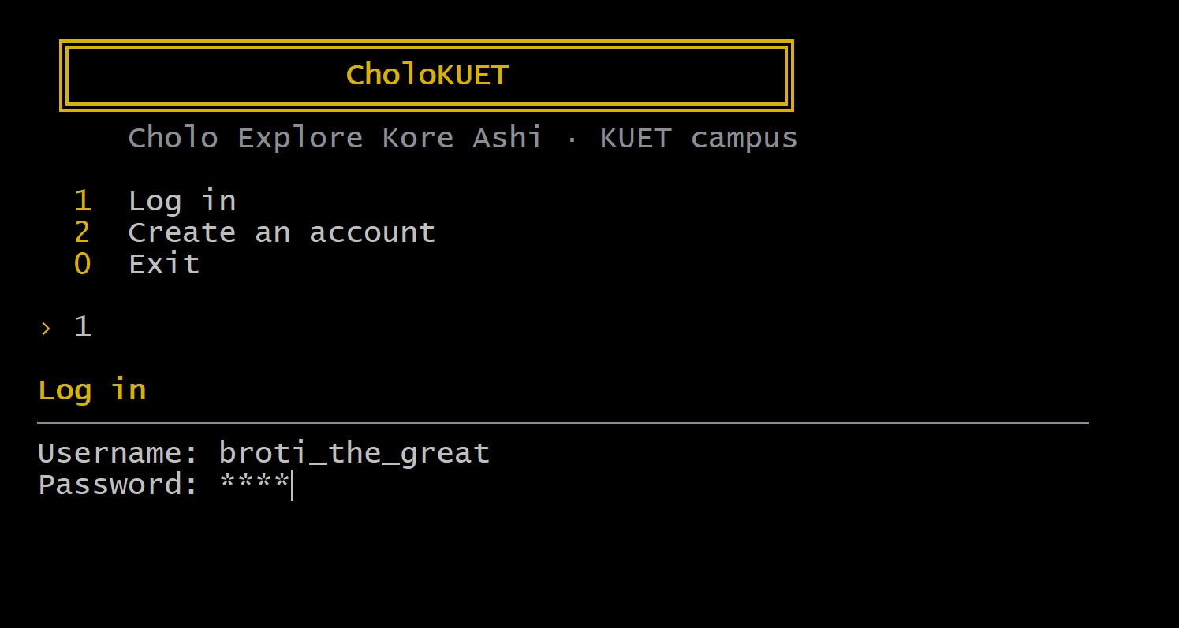 | 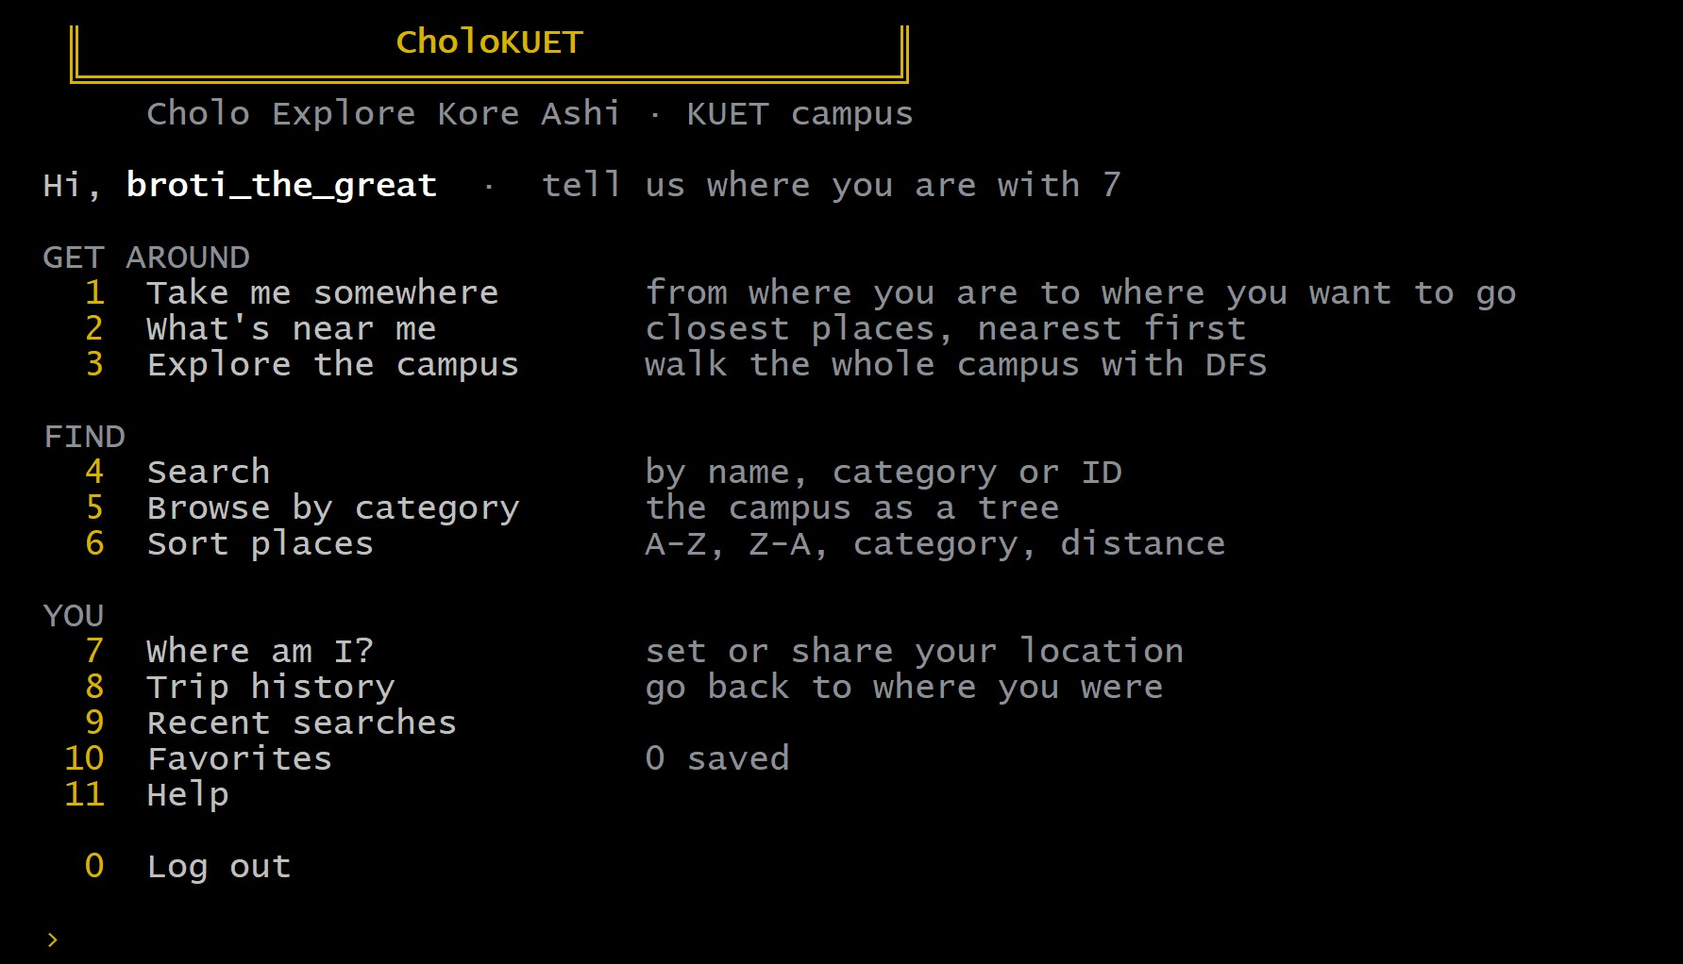
Figure 5. Logging in (left) and the main menu (right).

10.2 Take me somewhere
We typed only Main and Caf, and the app completed them to KUET Main Gate and Cafeteria. BFS found a route of 411 m, about 6 minutes, and merged its four walkways into two steps, one for each road (Figure 6). Under the directions the app lists every stop with its leg and running total, and says plainly that BFS gives the fewest stops, which is not always the shortest walk. Choosing I'm going sets the Cafeteria as the current location and pushes the trip onto the history stack (Figure 7).
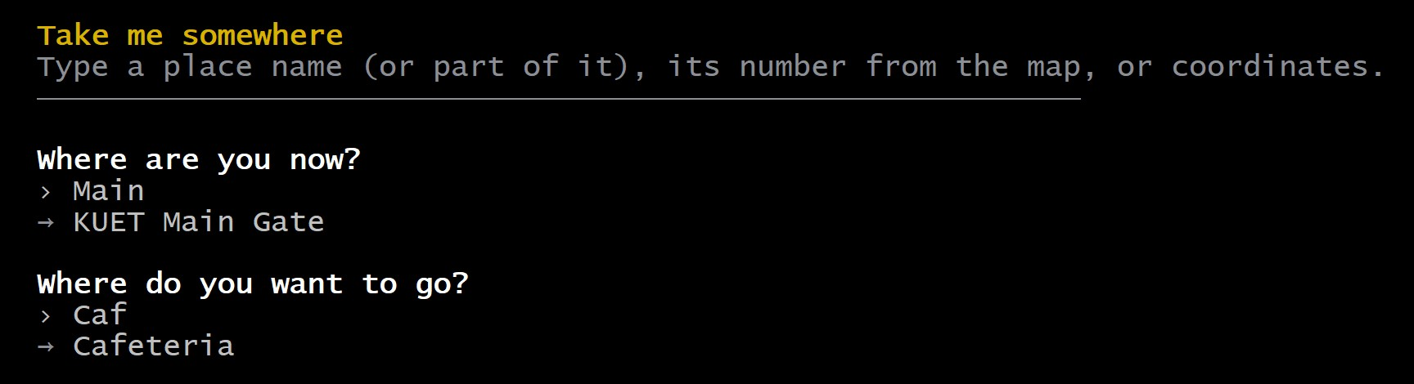 | 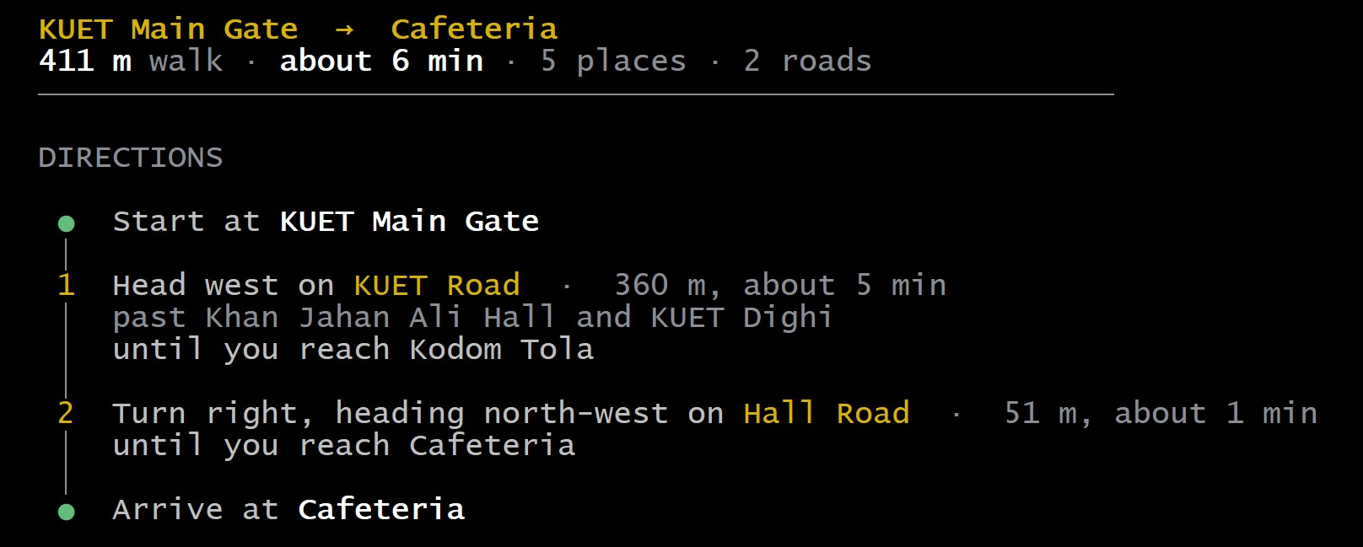
Figure 6. Take me somewhere: two partial names (left) become directions by road (right).
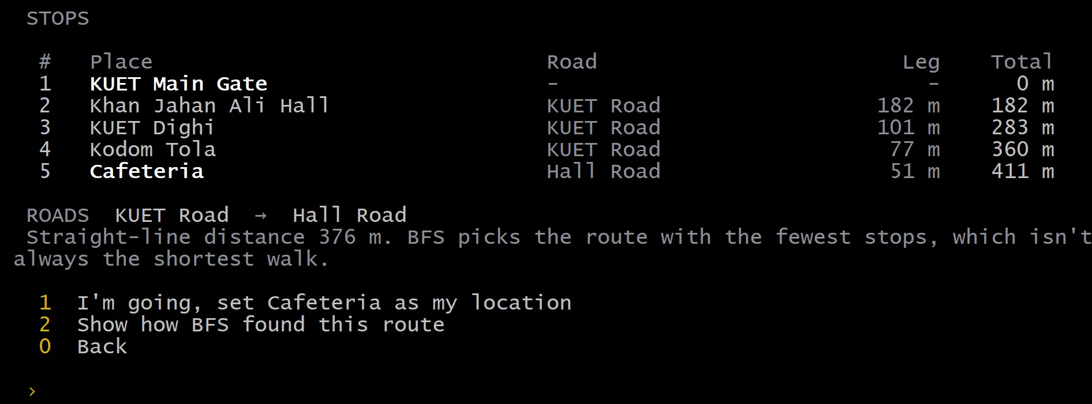 | 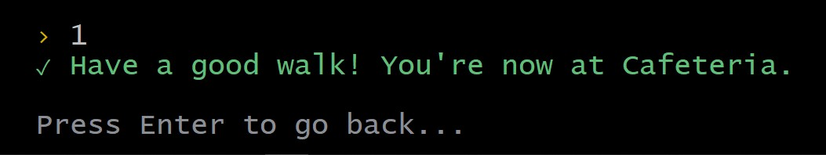
Figure 7. Every stop on the route (left), and the confirmation after choosing I'm going (right).
A longer trip reads the same way. From the Central Library to the main gate, nine stops are merged into three steps:
Central Library → KUET Main Gate
707 m walk · about 10 min · 9 places · 3 roads

DIRECTIONS
● Start at Central Library
1 Head south on Library Lane · 89 m, about 2 min
│ until you reach Fazlul Haque Hall
2 Turn left, heading east on Hall Road · 258 m, about 4 min
│ past Shaheed Smrity Hall, Dr. M. A. Rashid Hall and Cafeteria
│ until you reach Kodom Tola
3 Turn left, heading east on KUET Road · 360 m, about 5 min
│ past KUET Dighi and Khan Jahan Ali Hall
● Arrive at KUET Main Gate

STOPS
# Place Road Leg Total
1 Central Library - - 0 m
2 Fazlul Haque Hall Library Lane 89 m 89 m
3 Shaheed Smrity Hall Hall Road 80 m 169 m
4 Dr. M. A. Rashid Hall Hall Road 58 m 227 m
5 Cafeteria Hall Road 69 m 296 m
6 Kodom Tola Hall Road 51 m 347 m
7 KUET Dighi KUET Road 77 m 424 m
8 Khan Jahan Ali Hall KUET Road 101 m 525 m
9 KUET Main Gate KUET Road 182 m 707 m

ROADS Library Lane → Hall Road → KUET Road

10.3 What's near me and the place page
What's near me measures the distance from where we stand, the Cafeteria, to all 44 places, sorts them with bubble sort and lists the nearest ten with a direction and a walking time. It also reports the work done: 946 comparisons and 473 swaps (Figure 8). Picking a number opens that place's page, with its category, coordinates and walkways. From there Take me here runs the same BFS without asking for a start: 90 m to the post office, about 2 minutes (Figure 9).
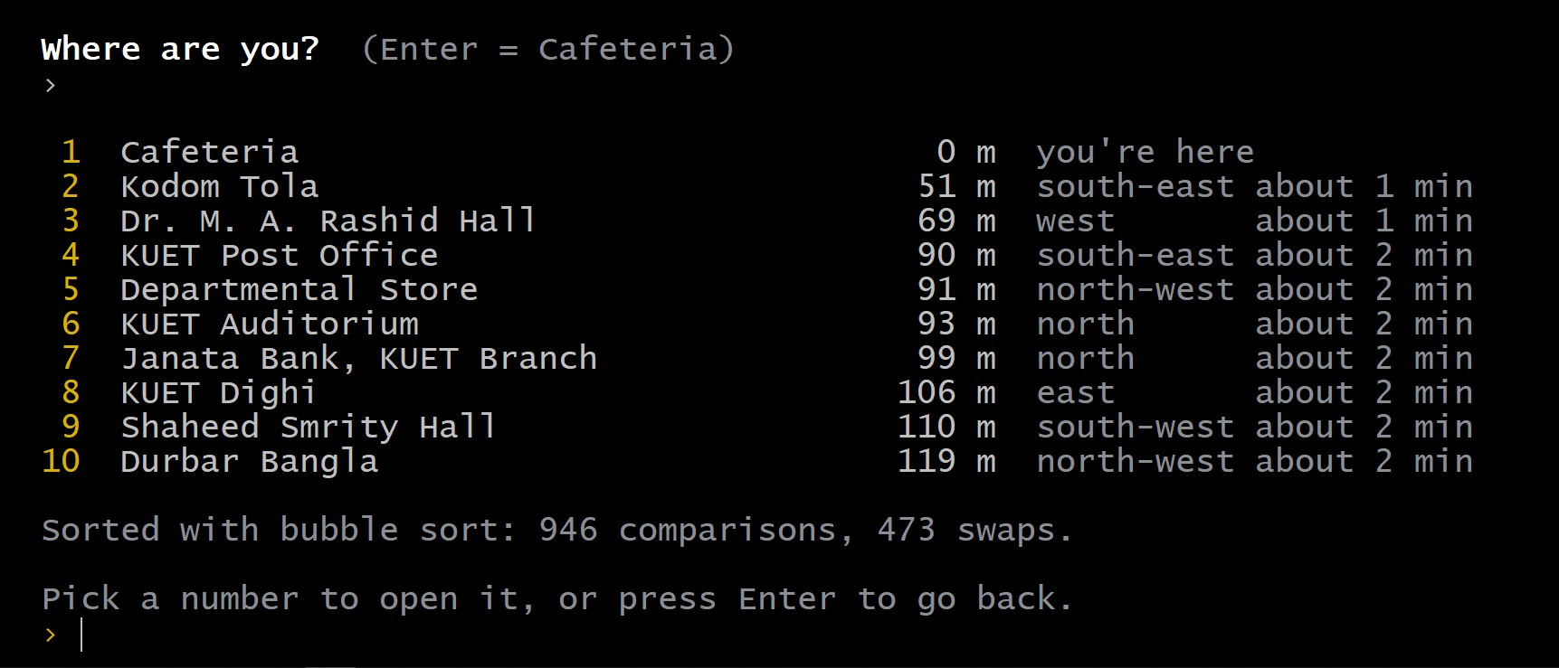
Figure 8. What's near me, from the Cafeteria.
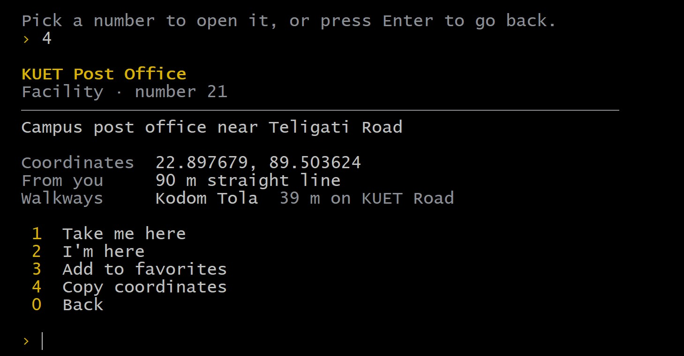 | 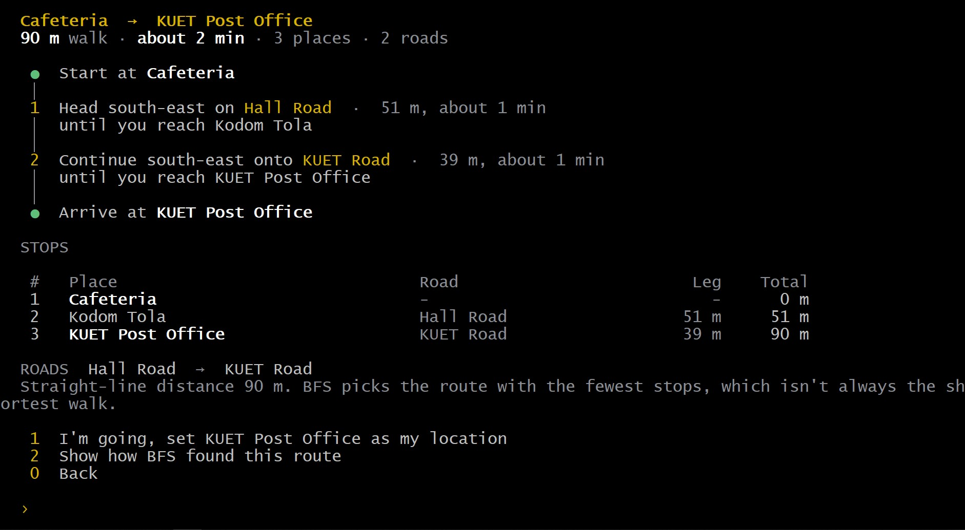
Figure 9. The place page for KUET Post Office (left) and the route from Take me here (right).

10.4 Explore the campus
Explore the campus has three options. The first walks the campus depth first from a chosen place and can print our stack at every push. The second is the connectivity check: DFS from the main gate reached 44 of 44 places (Figure 10). The third prints the graph as the app stores it, each road followed by its walkways and their lengths (Figure 11).
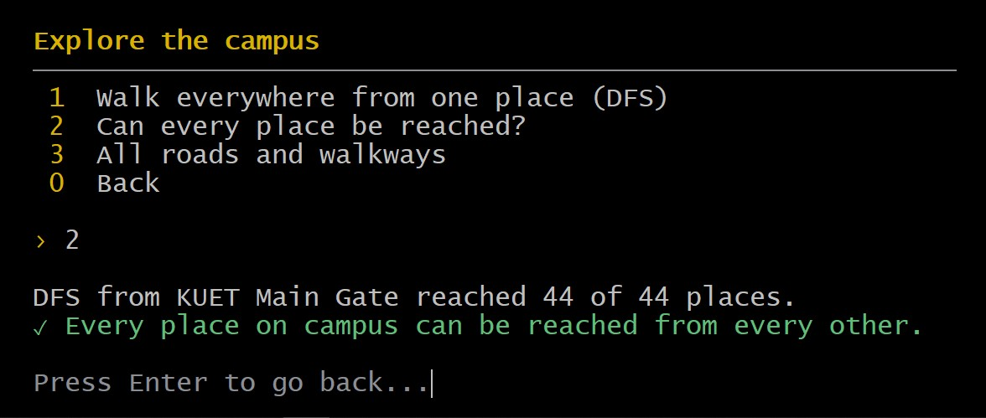 | 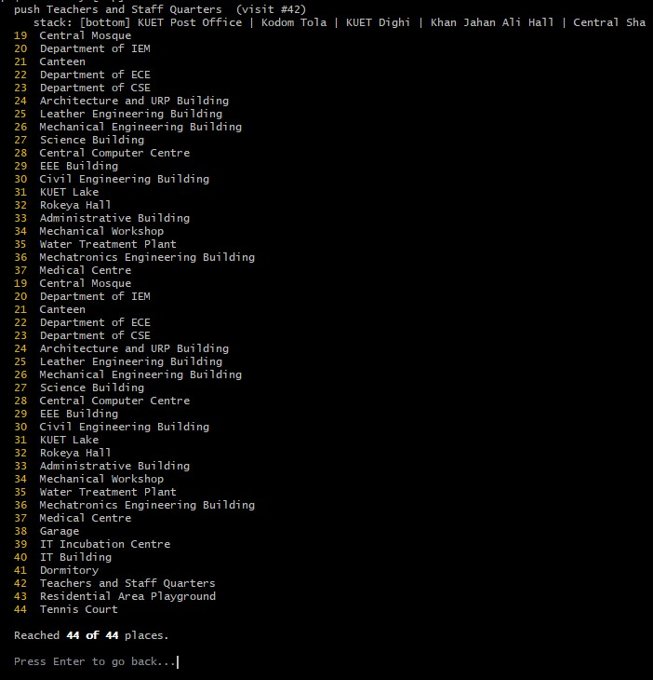
Figure 10. The Explore menu with the connectivity check (left), and the end of a DFS walk with the stack shown (right).
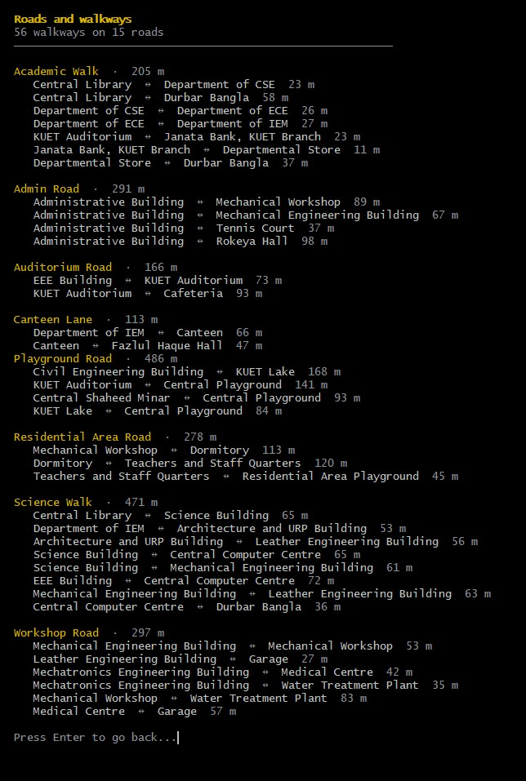
Figure 11. Part of the roads and walkways list, shown here in two columns.

10.5 Search and sort
Search is one box for names, categories and numbers. caf is not an exact name, so linear search checks all 44 places and finds the Cafeteria. Sort places offers four orderings and names the algorithm behind each one (Figure 12).
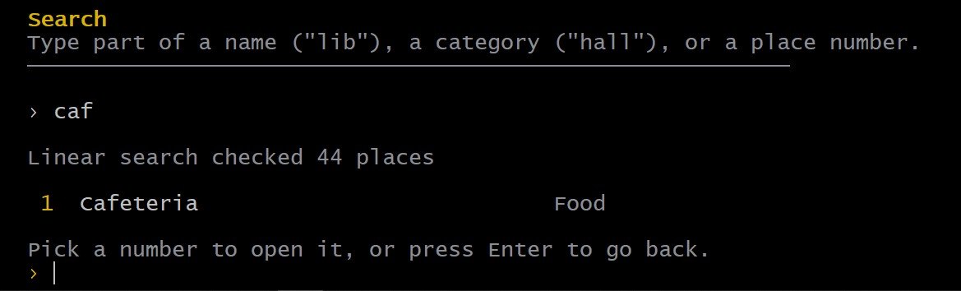 | 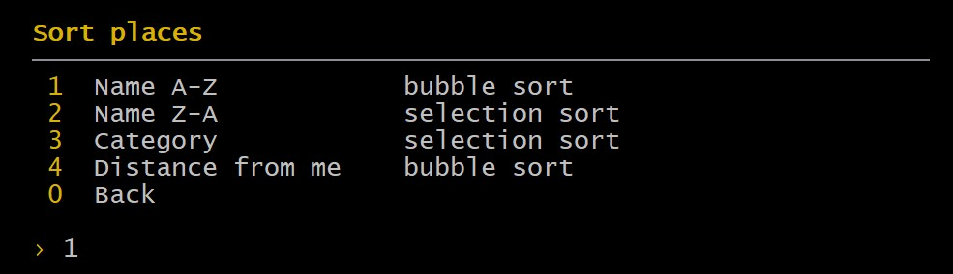
Figure 12. Searching for caf (left) and the Sort places menu (right).

10.6 Location, history and favorites
Where am I? shows the current place with its coordinates and lets the user set or copy them. Trip history is our stack on screen: the top is where we are now, and each Back pops it until the history is empty (Figures 13 and 14). Add to favorites on a place page saves the place for that user, so it is still listed under Favorites the next time they log in. Back on the welcome screen, 0 closes the program (Figure 15).
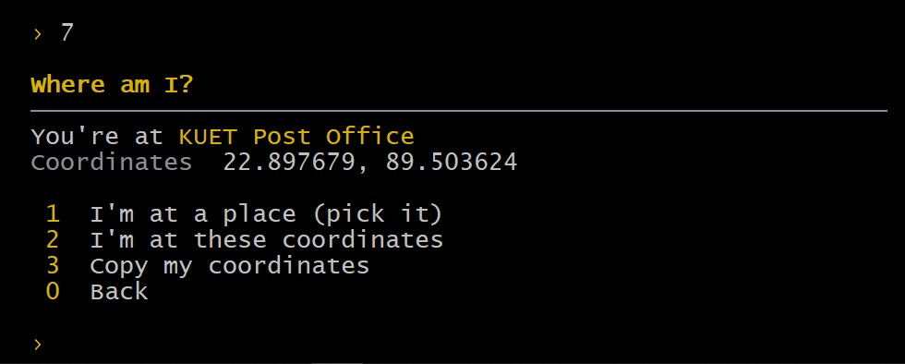 | 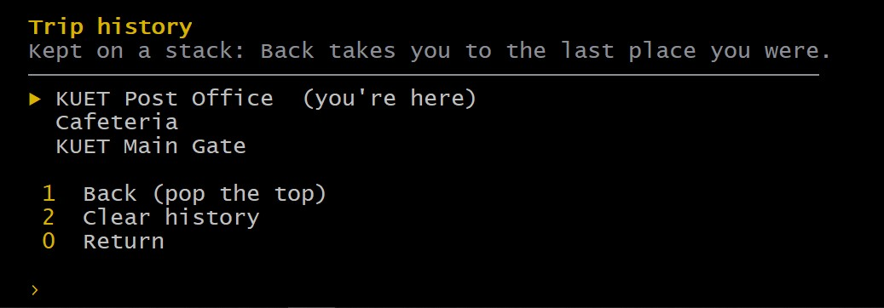
Figure 13. Where am I? (left) and Trip history, kept on a stack (right).
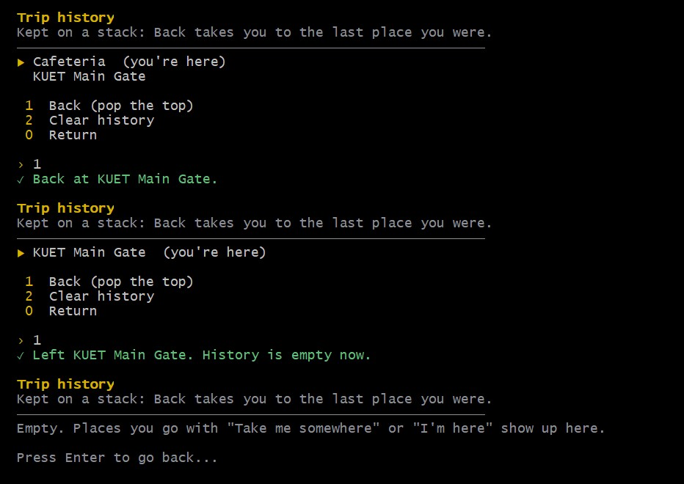 | 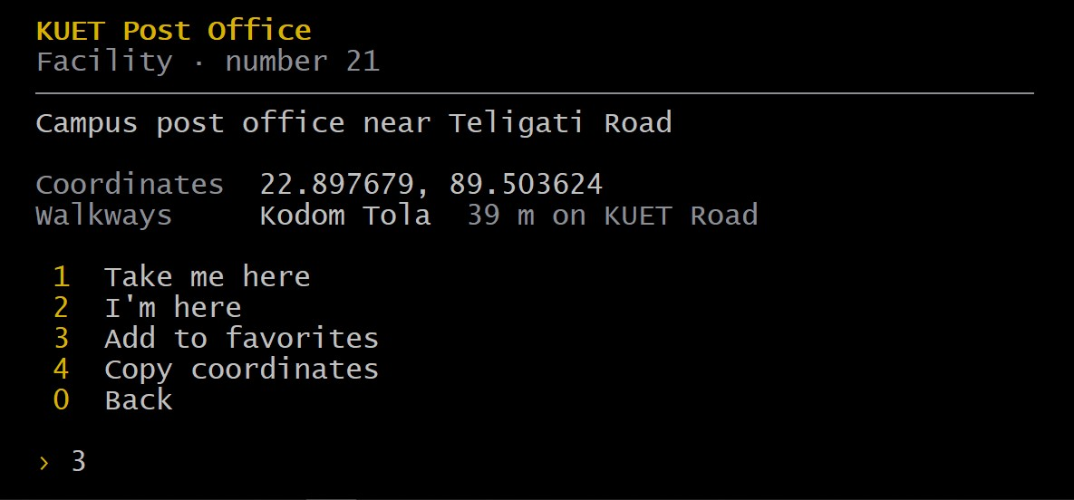
Figure 14. Back pressed twice, until the history is empty (left), and adding a place to favorites (right).
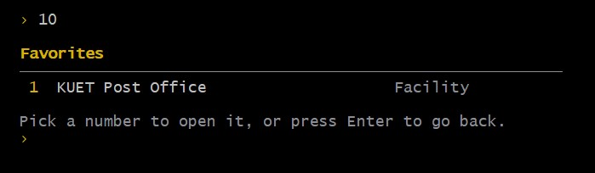 | 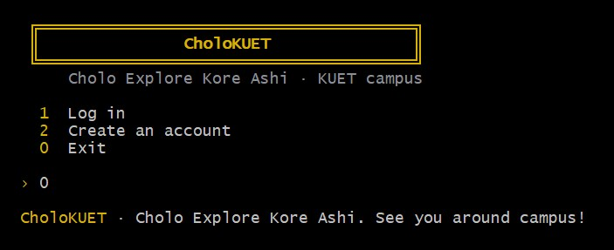
Figure 15. The favorites list (left) and leaving the app (right).

11. Limitations
- Fewest stops, not fewest meters. BFS ignores walkway length, so the suggested route can be a little longer in meters than the best one.
- Six positions are estimates. Fazlul Haque Hall, the Central Mosque, the Canteen, the Garage, the Dormitory and Kodom Tola come from the master plan and are accurate to about 30 m.
- Most road names are ours. Only KUET Road and Khanjahan Ali Hall Road are official names from OSM.
- Buildings only. There are no floors, rooms or labs yet.
- Walkways are simplified. They follow the plan's roads; short cuts and newer paths are missing.
- No live location. The user types a place or coordinates instead of reading GPS.
- Demo-level login. FNV-1a is fast to brute-force; a real system would use bcrypt or Argon2.
- Terminal only. The map picture is generated separately, not shown inside the program.

12. How We Can Improve It
Each of these should be a contained change, because the data structures do not depend on the menus.

12.1 Better routes
- Dijkstra's algorithm for the shortest walk in meters. Every walkway already stores its length, so only a priority queue and a new shortestRoute() are needed. The app could show both routes side by side.
- A* search using the straight-line (Haversine) distance as the heuristic, to find the same shortest route while exploring fewer places.
- Accessible routes by giving walkways extra properties (stairs, ramp, unpaved) and skipping the ones a user wants to avoid.
- Time-aware routes, for example avoiding gates that close at night.

12.2 Better data
- Survey the six estimated buildings with a phone GPS and add them to OpenStreetMap, so the map improves for everyone.
- Add the real names of internal roads once confirmed by the university.
- Go one level deeper in the tree: floors, rooms and labs inside each building ("CSE Lab 3").
- Store data in SQLite instead of text files once many admins edit it at once.

12.3 Better experience
- A graphical, clickable map (Qt, SFML or a web front end) on top of the same C++ core.
- A phone app that reads live GPS and snaps it to the nearest building.
- A Bangla interface, and spoken turn-by-turn directions.
- Search that tolerates typos ("libary" → Library) using edit distance.

12.4 Better engineering
- Replace the demo password hash with bcrypt or Argon2.
- Automatic builds and tests on every push with GitHub Actions.
- A packaged Windows installer with a Start-menu shortcut.

References
- T. H. Cormen, C. E. Leiserson, R. L. Rivest, C. Stein, Introduction to Algorithms, 3rd ed., MIT Press, 2009. Chapters on elementary data structures, BFS, DFS and sorting.
- OpenStreetMap contributors, KUET campus data, © OpenStreetMap contributors, Open Database Licence (ODbL).
- Proposed Revised Master Plan of KUET Khulna Campus.
- R. W. Sinnott, "Virtues of the Haversine", Sky and Telescope, 68(2), 1984.
- I. Kalnytskyi, termcolor: a header-only C++ library for printing coloured messages, BSD 3-Clause licence.

Appendix A. Data Structure Walkthroughs
These walkthroughs were recorded from the program, running our own Stack, Queue, Tree, BFS, search and sort code on the real campus data. They show the state of each structure after every operation.

A.1 Array
Insert four places at the end:
[0] CSE
[1] Library
[2] EEE
[3] Main Gate
Size = 4

Access array[1] directly: Library

Remove index 0 (everything after it shifts left):
[0] Library
[1] EEE
[2] Main Gate

The real location list is an array too: 44 of 200 slots used.

Complexity: access O(1), append O(1), delete/search O(n)

A.2 Linked list
insertBack(CSE), insertBack(Library), insertBack(EEE)
HEAD → CSE → Library → EEE → NULL

insertFront(Main Gate)
HEAD → Main Gate → CSE → Library → EEE → NULL

remove(Library)
HEAD → Main Gate → CSE → EEE → NULL

contains(EEE)? yes

A real BFS route is stored the same way:
HEAD → KUET Main Gate → Khan Jahan Ali Hall → Central Shaheed Minar → Central Playground → KUET Auditorium → Janata Bank, KUET Branch → Departmental Store → Durbar Bangla → Central Library → NULL

Complexity: insert at head/tail O(1), search/remove O(n)

A.3 Stack (hand-written, dsa/stack)
PUSH 10
PUSH 20
PUSH 30

TOP (top = 2)
↓
30
20
10

POP → 30

TOP (top = 1)
↓
20
10

PEEK → 20 (not removed)

Popping an empty stack: underflow, refused

With campus places, like the navigation history:
TOP (top = 3)
↓
Central Library
Mechanical Engineering Building
Administrative Building
KUET Main Gate

Complexity: push O(1), pop O(1), peek O(1)

A.4 Queue (hand-written circular queue, dsa/queue)
ENQUEUE 10
ENQUEUE 20
ENQUEUE 30

FRONT → 10 20 30 ← REAR

DEQUEUE → 10

FRONT → 20 30 ← REAR
front index = 1, rear index = 2

Wraparound: fill the queue, dequeue 2, enqueue 2 more.
front index = 2, rear index = 1 → the rear wrapped back to the start of the array
Enqueue on a full queue: overflow, refused

With campus places, the way BFS uses it:
FRONT → KUET Main Gate, Khan Jahan Ali Hall, KUET Auditorium ← REAR

Complexity: enqueue O(1), dequeue O(1)
After filling all 200 slots and dequeuing two, the next values go into slots 0 and 1: the rear wraps round to the start of the array while the front is still at slot 2.

A.5 Tree
A small general tree (any number of children per node):

KUET
├── Academic
│ ├── CSE
│ └── EEE
├── Facilities
│ ├── Library
│ └── Auditorium
└── Residential

Preorder traversal (node first, then its children):
1. KUET
2. Academic
3. CSE
4. EEE
5. Facilities
6. Library
7. Auditorium
8. Residential

Parent of CSE is Academic; CSE and EEE are siblings.
Nodes: 8, height: 3

The real campus tree has 55 nodes, 10 categories, height 3.

Complexity: traversal O(n), search O(n)

A.6 BFS from the main gate to the Central Library
Each step dequeues one place and enqueues its unvisited neighbours, recording parent. When the library is dequeued, the parent chain is pushed on our stack and popped off in forward order.
Start at KUET Main Gate
FRONT → KUET Main Gate ← REAR

Step 1: dequeue KUET Main Gate
enqueue Khan Jahan Ali Hall (parent: KUET Main Gate)
FRONT → Khan Jahan Ali Hall ← REAR

Step 2: dequeue Khan Jahan Ali Hall
enqueue Central Shaheed Minar (parent: Khan Jahan Ali Hall)
enqueue KUET Dighi (parent: Khan Jahan Ali Hall)
FRONT → Central Shaheed Minar, KUET Dighi ← REAR

Step 3: dequeue Central Shaheed Minar
enqueue Central Playground (parent: Central Shaheed Minar)
FRONT → KUET Dighi, Central Playground ← REAR

Step 4: dequeue KUET Dighi
enqueue Kodom Tola (parent: KUET Dighi)
FRONT → Central Playground, Kodom Tola ← REAR

Step 5: dequeue Central Playground
enqueue KUET Auditorium (parent: Central Playground)
enqueue KUET Lake (parent: Central Playground)
FRONT → Kodom Tola, KUET Auditorium, KUET Lake ← REAR

Step 6: dequeue Kodom Tola
enqueue KUET Post Office (parent: Kodom Tola)
enqueue Cafeteria (parent: Kodom Tola)
FRONT → KUET Auditorium, KUET Lake, KUET Post Office, Cafeteria ← REAR

Step 7: dequeue KUET Auditorium
enqueue Janata Bank, KUET Branch (parent: KUET Auditorium)
enqueue EEE Building (parent: KUET Auditorium)
FRONT → KUET Lake, KUET Post Office, Cafeteria, Janata Bank, KUET Branch, EEE Building ← REAR

Step 8: dequeue KUET Lake
enqueue Civil Engineering Building (parent: KUET Lake)
FRONT → KUET Post Office, Cafeteria, Janata Bank, KUET Branch, EEE Building, Civil Engineering Building ← REAR

Step 9: dequeue KUET Post Office
FRONT → Cafeteria, Janata Bank, KUET Branch, EEE Building, Civil Engineering Building ← REAR

Step 10: dequeue Cafeteria
enqueue Dr. M. A. Rashid Hall (parent: Cafeteria)
FRONT → Janata Bank, KUET Branch, EEE Building, Civil Engineering Building, Dr. M. A. Rashid Hall ← REAR

Step 11: dequeue Janata Bank, KUET Branch
enqueue Departmental Store (parent: Janata Bank, KUET Branch)
FRONT → EEE Building, Civil Engineering Building, Dr. M. A. Rashid Hall, Departmental Store ← REAR

Step 12: dequeue EEE Building
enqueue Central Computer Centre (parent: EEE Building)
FRONT → Civil Engineering Building, Dr. M. A. Rashid Hall, Departmental Store, Central Computer Centre ← REAR

Step 13: dequeue Civil Engineering Building
enqueue Rokeya Hall (parent: Civil Engineering Building)
FRONT → Dr. M. A. Rashid Hall, Departmental Store, Central Computer Centre, Rokeya Hall ← REAR

Step 14: dequeue Dr. M. A. Rashid Hall
enqueue Shaheed Smrity Hall (parent: Dr. M. A. Rashid Hall)
FRONT → Departmental Store, Central Computer Centre, Rokeya Hall, Shaheed Smrity Hall ← REAR

Step 15: dequeue Departmental Store
enqueue Durbar Bangla (parent: Departmental Store)
FRONT → Central Computer Centre, Rokeya Hall, Shaheed Smrity Hall, Durbar Bangla ← REAR

Step 16: dequeue Central Computer Centre
enqueue Science Building (parent: Central Computer Centre)
FRONT → Rokeya Hall, Shaheed Smrity Hall, Durbar Bangla, Science Building ← REAR

Step 17: dequeue Rokeya Hall
enqueue Administrative Building (parent: Rokeya Hall)
FRONT → Shaheed Smrity Hall, Durbar Bangla, Science Building, Administrative Building ← REAR

Step 18: dequeue Shaheed Smrity Hall
enqueue Fazlul Haque Hall (parent: Shaheed Smrity Hall)
enqueue Amar Ekushey Hall (parent: Shaheed Smrity Hall)
FRONT → Durbar Bangla, Science Building, Administrative Building, Fazlul Haque Hall, Amar Ekushey Hall ← REAR

Step 19: dequeue Durbar Bangla
enqueue Central Library (parent: Durbar Bangla)
FRONT → Science Building, Administrative Building, Fazlul Haque Hall, Amar Ekushey Hall, Central Library ← REAR

Step 20: dequeue Science Building
enqueue Mechanical Engineering Building (parent: Science Building)
FRONT → Administrative Building, Fazlul Haque Hall, Amar Ekushey Hall, Central Library, Mechanical Engineering Building ← REAR

Step 21: dequeue Administrative Building
enqueue Mechanical Workshop (parent: Administrative Building)
enqueue Tennis Court (parent: Administrative Building)
FRONT → Fazlul Haque Hall, Amar Ekushey Hall, Central Library, Mechanical Engineering Building, Mechanical Workshop, Tennis Court ← REAR

Step 22: dequeue Fazlul Haque Hall
enqueue Canteen (parent: Fazlul Haque Hall)
FRONT → Amar Ekushey Hall, Central Library, Mechanical Engineering Building, Mechanical Workshop, Tennis Court, Canteen ← REAR

Step 23: dequeue Amar Ekushey Hall
enqueue Lalan Shah Hall (parent: Amar Ekushey Hall)
FRONT → Central Library, Mechanical Engineering Building, Mechanical Workshop, Tennis Court, Canteen, Lalan Shah Hall ← REAR

Step 24: dequeue Central Library

Walking back through parent[] from Central Library to KUET Main Gate and pushing each stop:
TOP (top = 8)
↓
KUET Main Gate
Khan Jahan Ali Hall
Central Shaheed Minar
Central Playground
KUET Auditorium
Janata Bank, KUET Branch
Departmental Store
Durbar Bangla
Central Library
Popping the stack gives the route from the start.

Route: KUET Main Gate → Khan Jahan Ali Hall → Central Shaheed Minar → Central Playground → KUET Auditorium → Janata Bank, KUET Branch → Departmental Store → Durbar Bangla → Central Library

Complexity: O(V + E); gives the fewest stops in an unweighted graph

A.7 Linear and binary search
Linear search for "Central Library" in the unsorted list:
Result: Central Library (checked all 44 items)
Linear search for ID 30 stopped after 30 comparisons (found)

Binary search needs sorted data, so sort a copy by name first.

low=0 mid=21 high=43 "IT Building" → go left
low=0 mid=10 high=20 "Civil Engineering Building" → go left
low=0 mid=4 high=9 "Canteen" → go right
low=5 mid=7 high=9 "Central Mosque" → go left
low=5 mid=5 high=6 "Central Computer Centre" → go right
low=6 mid=6 high=6 "Central Library" → found

Result: Central Library (6 comparisons)

Complexity: linear O(n), binary O(log n) but only on sorted data

A.8 Bubble sort and selection sort, pass by pass
Before: KUET Main Gate; Department of ECE; EEE Building; Mechatronics Engineering Building; Central Computer Centre; KUET Post Office

Bubble sort A-Z:
Pass 1: [Department of ECE, EEE Building, KUET Main Gate, Central Computer Centre, KUET Post Office, Mechatronics Engineering Building]
Pass 2: [Department of ECE, EEE Building, Central Computer Centre, KUET Main Gate, KUET Post Office, Mechatronics Engineering Building]
Pass 3: [Department of ECE, Central Computer Centre, EEE Building, KUET Main Gate, KUET Post Office, Mechatronics Engineering Building]
Pass 4: [Central Computer Centre, Department of ECE, EEE Building, KUET Main Gate, KUET Post Office, Mechatronics Engineering Building]
Pass 5: [Central Computer Centre, Department of ECE, EEE Building, KUET Main Gate, KUET Post Office, Mechatronics Engineering Building]
Comparisons: 15, swaps: 7

Selection sort A-Z:
Pass 1: [Central Computer Centre, Department of ECE, EEE Building, Mechatronics Engineering Building, KUET Main Gate, KUET Post Office]
Pass 2: [Central Computer Centre, Department of ECE, EEE Building, Mechatronics Engineering Building, KUET Main Gate, KUET Post Office]
Pass 3: [Central Computer Centre, Department of ECE, EEE Building, Mechatronics Engineering Building, KUET Main Gate, KUET Post Office]
Pass 4: [Central Computer Centre, Department of ECE, EEE Building, KUET Main Gate, Mechatronics Engineering Building, KUET Post Office]
Pass 5: [Central Computer Centre, Department of ECE, EEE Building, KUET Main Gate, KUET Post Office, Mechatronics Engineering Building]
Comparisons: 15, swaps: 3

Bubble swaps neighbours many times; selection makes at most n-1 swaps.
Bubble sort is stable, selection sort is not.

Complexity: both O(n^2); bubble sort is O(n) when already sorted

Appendix B. Building and Running
- Install g++ through MSYS2 (pacman -S mingw-w64-ucrt-x86_64-gcc) and add C:\msys64\ucrt64\bin to PATH.
- Open a terminal in the project folder and run make run. It builds bin/CholoKUET.exe with the logo icon and starts it. make test builds and runs all eight test programs.
- Without make, g++ -std=c++17 main.cpp -o CholoKUET builds the whole program in one command, because main.cpp pulls in every other source file.
- Log in as student1 / student123, or as admin / admin123 for the admin menus.

